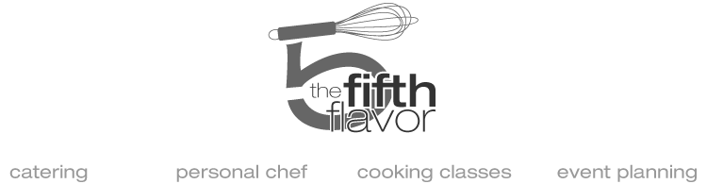

New England Barn Dinner

passed hors d’oeuvres
trio of crostini:
butternut squash with goat cheese + pomegranate;
eggplant, charred pepper + shaved pecorino;
roasted grape, cambozola + pistachio
***
chilled shrimp + avocado toast with lemon + chile flake
***
twice-baked mini potatoes with bacon, brie + chive
***
mini waffles with cured salmon, charred orange-fennel relish + crème fraîche

buffet dinner

wedge salad with roasted cherry tomatoes, crispy prosciutto, pickled onion + “cucumber ranch”
***
“street corn” salad with roasted poblano chilies, fresh herbs, lemon aioli + crumbled cotija cheese
***
roasted beet and apple salad with crunchy seed “granola” and mint labneh
***
grilled lobster halves, with garlic parsley butter;
shoestring potatoes, curry ketchup and bacon fat mayo
***
NY strip steaks, seared mid-rare and sliced; salsa verde butter + sautéed local mushrooms

"pie bar"
espresso truffle tart with olive oil pistachios + whipped mascarpone;
fried apple hand pies with 5-spice sugar;
citrus curd pie with fresh berries and whipped cream;
butterscotch pie with marshmallow meringue and chocolate;
individual warm blueberry cobblers with honey lavender ice cream

